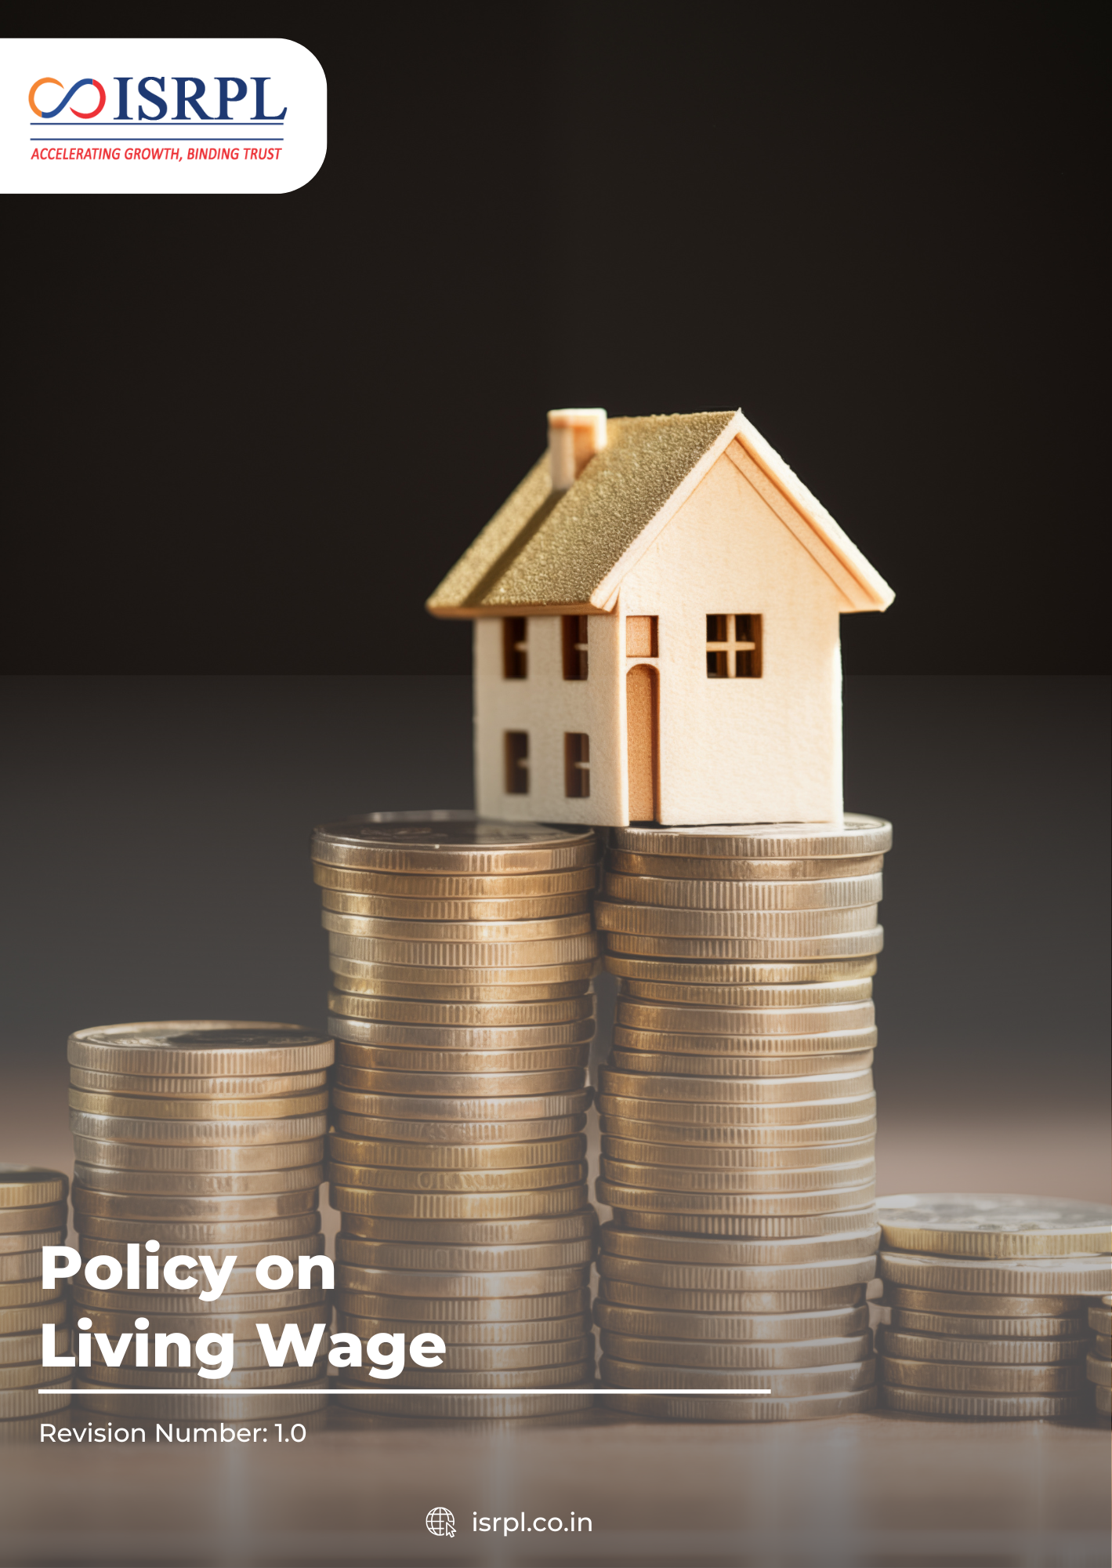
Contents

Introduction 3
Scope 3
Purpose 3
Key Focus Areas 4
Policy Commitments 4
Targets 5
SDGs Covered 7
Roles & Responsibilities 7
Reporting 8
Continuous Improvement 8
Review Mechanism 8
Acknowledgement 10

Introduction
Indian Synthetic Rubber Private Limited (ISRPL) is committed to ensuring fair and responsible compensation for all employees in line with applicable laws and ethical business practices. The company recognizes that paying a living wage supports employee well-being, financial security, and dignity at work. Through this policy, ISRPL aims to promote equitable wages that help employees meet their basic needs and improve their overall quality of life.

Scope
This policy applies to all activities, products, and services of ISRPL, including its Corporate Office in Noida and its manufacturing facility in Panipat, Haryana. It extends to all employees, contractors, vendors, and stakeholders operating within or on behalf of ISRPL premises.
Sr. No. | Name of Company | Function of Site | Address
1 | Indian Synthetic Rubber Private Limited | Corporate Office | 1st Floor, Tower 3, IGL Complex,  Plot No-2B, Sector-126, Noida, Uttar Pradesh -201304
2 | Indian Synthetic Rubber Private Limited | Registered Office | 10th Floor, Core-2, North Tower, Scope Minar, District Centre, Laxmi Nagar, Delhi -110092
3 | Indian Synthetic Rubber Private Limited | Manufacturing Plant | Opposite: Naptha Cracker Polymer Terminal Gate, Panipat Refinery, Panipat, Haryana -132140

Purpose
The purpose of this policy is to establish ISRPL’s commitment to providing fair and adequate wages that meet employees’ basic needs, ensure financial security, and promote a responsible, ethical, and sustainable compensation framework across the organization.

Principles and Practices Followed for Living Wage
ISRPL ensures that all employees receive fair and adequate compensation by strictly adhering to the Code on Wages, 2019 and other applicable local minimum wage laws and regulations. The company benchmarks wages against recognized living wage standards and industry best practices, regularly reviewing them to account for inflation and cost-of-living changes. This commitment extends to all employees, including contract and temporary workers, and ISRPL also encourages suppliers to adopt similar living wage principles. Transparent records of wage decisions are maintained and communicated to promote accountability and fairness across the organization.

How Living Wage is Calculated
Living Wage Components (for a family of 4):
Component | Description / Basis
Food & Nutrition | Sufficient for 4 members to meet daily dietary needs
Housing | Safe and adequate accommodation for family
Healthcare | Access to medical care and medicines
Education | Schooling and educational materials for children
Transportation | Daily commuting and essential travel costs
Other Essentials | Clothing, personal care, utilities, and contingency expenses
Calculation Basis:
- Benchmarked against national living wage standards
- Reviewed annually to account for inflation and cost-of-living changes
- Ensures all employees and their families can maintain a decent standard of living

Key Focus Areas
- Ensure all wages comply with the applicable local labor laws.
- Regularly benchmark wages against recognized living wage standards and industry best practices, reviewing them annually to account for inflation and cost-of-living changes.
- Extend living wage principles to all employees, including contract, temporary, and casual workers.
- Encourage suppliers and contractors to adopt similar living wage practices within their operations.
- Maintain clear records of wage decisions and communicate policies and updates to employees to ensure accountability and understanding.
- Promote overall employee well-being, financial security, and dignity through fair and responsible compensation.

Policy Commitments
- We aim to provide fair compensation to all employees by benchmarking wages against recognized living wage standards to ensure financial security and dignity for employees and their families.
- We aim to implement regular wage reviews by monitoring cost-of-living changes and industry best practices to maintain equitable and up-to-date compensation.
- We aim to calculate living wages using approved and recognized methods by applying standard benchmarks and cost-of-living assessments to ensure accuracy and fairness in compensation.
- We aim to cover all employees in living wage benchmark analysis by including permanent, contract, and temporary staff to ensure equitable compensation across the organization.
- We aim to maintain transparency and accountability by keeping clear records of wage payments and policy adherence to demonstrate responsibility and build trust with employees and stakeholders.

Targets
- Aim to ensure 100% permanent, contract, and temporary employees receive wages at or above the recognized living wage standard by FY 2030–31, starting from the baseline of FY 2022–23.
- Aim to conduct annual wage benchmarking for 100% of employee categories to align with cost-of-living adjustments and recognized living wage standards by FY 2030–31.
- Aim to ensure at least 60% of employees receive annual wage adjustments based on cost-of-living changes and inflation.
- Ensure that living wage payment records and policy implementation status are documented and made transparent for at least 100% of employees and business units by FY 2030–31.
- Aim to maintain 100% compliance with the applicable labor laws across all operations by FY 2030–31.

SDGs Covered
 | 

Roles & Responsibilities
HR Head
- Review Policy regularly.
- Implement the living wage policy across all employee categories.
- Conduct wage benchmarking and annual reviews.
- Organize employee awareness sessions and trainings.
- Maintain records of employee acknowledgements related to the policy.
Finance Manager
- Ensure timely and accurate disbursement of wages in line with living wage standards.
- Maintain transparent wage payment records.
Procurement Head
- Engage suppliers and contractors on living wage compliance.
- Incorporate living wage considerations into supplier contracts.
- Monitor supplier adherence and report gaps to senior management.
- Conduct periodic supplier assessments to promote ethical wage practices.
Compliance Officer
- Monitor compliance with the Code on Wages, 2019 and other labor laws.
- Conduct internal audits to verify policy implementation.
- Report progress, gaps, and corrective actions to senior management.

Reporting
ISRPL will ensure systematic reporting on living wage implementation across all employee categories and supply chain partners. Wage benchmarking outcomes, employee coverage, and policy adherence will be documented and reviewed regularly. Reports will be submitted to senior management, and key findings communicated internally to enhance transparency, accountability, and continuous improvement in compensation practices.

Continuous Improvement
ISRPL is committed to continuously improving living wage practices across the organization. The company will regularly review wage structures, benchmark against industry standards, and incorporate employee and supplier feedback to enhance compensation fairness. Lessons learned from audits, monitoring, and reporting will guide corrective actions. This iterative process ensures wages remain equitable, aligned with cost-of-living changes, and support employee well-being and organizational sustainability over time.

Review Mechanism
ISRPL will review the Living Wage Policy annually or as required by changes in regulations, business operations, or stakeholder expectations. The review will be conducted by the HR Head and will assess wage structures, policy implementation, supplier compliance, and employee coverage. Recommendations from the review will guide updates to practices, ensuring alignment with cost-of-living changes, industry benchmarks, and organizational objectives.
Last Review Date: 01 Jan 2026
Next Review Date: 01 Jan 2027
Approved by:

Acknowledgement
I, , the undersigned, acknowledge that I have received, read, and understood the Living Wage Policy of Indian Synthetic Rubber Private Limited (ISRPL). I recognize the company’s commitment to fair and equitable compensation, transparency, employee well-being, and compliance with applicable laws and ethical standards.
I understand that:
- I am responsible for adhering to the principles and requirements outlined in this policy in my role.
- I will support the company’s efforts to ensure all employees receive wages aligned with recognized living wage standards.
- I will actively promote awareness of living wage principles and support their implementation within my team and work processes.
- I will promptly report any concerns regarding wage discrepancies, non-compliance, or unfair compensation practices through the appropriate reporting channels.
- Any clarification regarding this policy will be sought from the HR or Compliance Department.
By signing this acknowledgement, I confirm my commitment to uphold ISRPL’s Living Wage Policy and contribute to fostering fair, ethical, and sustainable compensation practices across the organization.

Employee Name:
Designation:
Department:
Date:
Signature:

